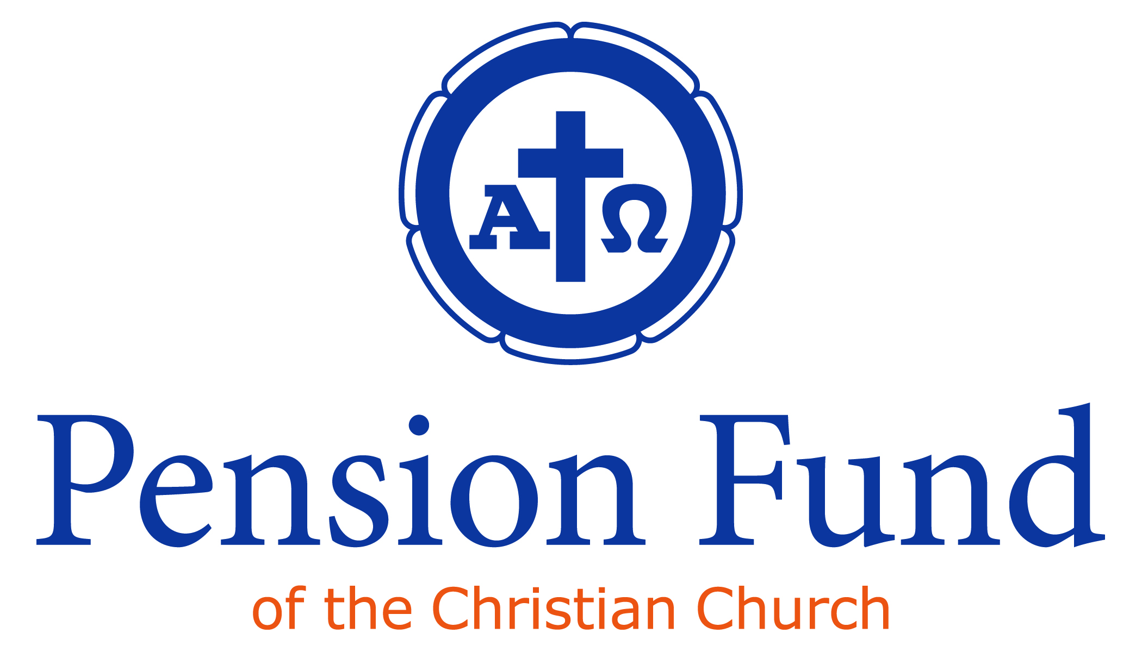

What Regional Ministers Should Know About
Ministerial Relief and Assistance (MR&A)

The mission of the Pension Fund of the Christian Church is to support the servants of the church. To this end, Pension Fund administers the Ministerial Relief and Assistance program on behalf of the church, partnering with Regional Ministers, as well as General Ministries, as they seek to care for ministers, their families and congregations in times of deepest need.

History and Background

Ministerial Relief and Assistance began in 1895 to assist retired and disabled ministers as well as their surviving spouses and minor children. The program has been expanded over the years and today includes Ministerial Relief pensions, Supplemental Gifts, Emergency Aid, Student Gift Membership grants, Health Care premium assistance, Reserve Chaplain dues assistance and 13th Check.

Regions are encouraged to demonstrate care and concern for ministers in their Regions by providing assistance when an immediate financial need arises. When need is greater than Regional resources can bear, then it is appropriate for Regions to partner with Pension Fund for Ministerial Relief and Assistance.

Many churches and individuals have made and continue to make generous contributions to the Ministerial Relief and Assistance Fund. Even so, funds are limited. In order to responsibly administer the program, applications are required for most Ministerial Relief programs. These application forms are available upon request from the Pension Fund.

Generally, ministers contact the Pension Fund directly to make a Ministerial Relief request. However, Regional Ministers and ministerial colleagues may contact the Pension Fund on behalf of a minister when they become aware of that minister’s financial need.

Active and retired, ordained and commissioned/licensed ministers are eligible for Ministerial Relief and Assistance. Persons who have left ministry are not eligible. In addition, retired lay church workers who are receiving Pension Plan retirement pensions are eligible for Supplemental Gifts under certain conditions.

Emergency Aid

The purpose of the Emergency Aid program is to assist ministers with large, unexpected financial obligations.

Who is eligible for Emergency Aid?
- All ordained, commissioned/licensed ministers, active and retired
What types of need are considered for Emergency Aid?
- Large, unexpected medical bills incurred by the minister or his/her dependent
- Funeral expenses for spouse, child or parent
- Transition expenses, i.e., basic living expenses when a minister is between ministerial calls
How does one apply for Emergency Aid?
- By written request. Minister contacts Pension Fund to obtain Emergency Aid Request and submits the completed form along with documents supporting the request (bills, statements, etc.)
When are Emergency Aid funds distributed?
- Generally, Emergency Aid provides a one-time grant and a check is issued upon approval by the Ministerial Relief and Assistance Committee.
- For transition situations, assistance is provided for 3 months or whenever the minister receives a new call, whichever occurs first. This grant is paid on the first business day each month of the assistance period.

Churchwide Health Care Premium Assistance

The purpose of the Churchwide Health Care Premium Assistance program is to assist Pension Plan members and their beneficiaries who cannot afford health care premiums due to certain life circumstances.

Who is eligible for Health Care Gift?
- Ministers awaiting a new Call (in “transition”)
- Ministers of new church starts
- Retired ministers and their surviving spouses with low incomes (generally receiving a Ministerial Relief pension or Supplemental Gift)
- Ministers receiving Pension Plan disability benefits
- Seminary students enrolled at least half-time in an M.Div. or equivalent program of ministerial education
How does one apply for a Health Care Gift?
- By written request. Contact Pension Fund in order to obtain the appropriate application form.
How are funds distributed?
- Premiums are paid directly to Churchwide Health Care each month of the assistance period.

Ministerial Relief Pensions
The purpose of Ministerial Relief Pension program is to assist retired ministers (and their surviving spouses) who were never afforded the opportunity to participate in the Pension Plan and whose retirement income is low (i.e., less than 200% of poverty level).

Who is eligible for a Ministerial Relief pension?
- Ministers, age 65 and retired from active ministry;
- NOT a Pension Plan member
- May be surviving spouse of minister who would have been eligible for Ministerial Relief Pension
How does one apply for a Ministerial Relief pension?
- By written request. Minister (or surviving spouse) completes a Ministerial Relief application, available from Pension Fund, providing the names of 3 references.
How are Ministerial Relief funds distributed?
- Ministerial Relief Pensions are treated like regular pensions and paid on the first business day of each month.

Supplemental Gifts

The purpose of the Supplemental Gift program is to assist Pension Plan members (and their surviving spouses) who have very low retirement income and where the low Pension Plan retirement pension is not the fault of the individual.

Who is eligible for Supplemental Gift?
- Ministers with 5 years of Pension Plan participation and lay church workers with 10 years of Pension Plan participation who are at least age 65 and retired from active ministry/church service
- Surviving spouses of those who were eligible for Supplemental Gift
How does one apply for Supplemental Gift?
- By written request. Individual completes and submits Supplemental Gift Application, available from Pension Fund.
How is the Supplemental Gift distributed?
- Supplemental Gifts are paid on first business day of each month along with the Pension Plan retirement pension.

13th Checks

The purpose of the 13th Check is to provide a year-end gift to beneficiaries with the lowest retirement incomes.

Who is eligible for a 13th Check?
- Those receiving a Ministerial Relief Pension or Supplemental Gift.
How does one apply for a 13th Check?
- There is no application. Recipients of Ministerial Relief Pensions or Supplement Gifts receive a 13th check automatically.
How are 13th Check funds distributed?
- Checks are sent at the end of November/beginning of December each year.

Student Gift Membership Grants

The purpose of the Student Gift Membership Grant program is to encourage early participation in the Pension Plan and to provide benefits to the student and family in the event of disability or untimely death.

Who is eligible for the Student Gift Membership program?
- Students “under care” of a Region; having completed at least 18 credit hours and currently enrolled in at least 6 credit hours at a seminary/divinity school, seeking a M.Div. or ministry equivalent degree.
How does one apply for a Student Gift Membership?
- Student completes the Student Gift Membership Application, obtains Regional and school authorizations and submits
How much is the grant?
- The grant pays pension dues of $70.00 per month, which provides full Pension Plan benefits based on a monthly salary of $500.00.
How long does the Student Gift Membership last?
- The gift membership is available for a maximum of 36 months.

Reserve Chaplain Dues

The purpose of the Reserve Chaplain dues program is to assist ministers whose civilian ministries are interrupted when called to active duty as military chaplains.

Who is eligible?
- Active Pension Plan members, employed and performing ministerial duties with the Church or related organization when called to military Active Duty
How does one apply for Reserve Chaplain dues assistance?
- Minister-Chaplain submits copy of Active Duty orders
How much is the grant?
- The grant pays dues of $110.00 per month, which is 11% of $1,000.00. The ministerial member is required to pay the remaining 3%, which is $30.00 per month.
How long does the Reserve Chaplain dues program last?
- Dues assistance terminates when active duty orders expire.

Summary
You, the Regional Minister, have identified a minister in your Region who needs financial assistance. While some ministers may qualify for more than one program, no one is eligible for all Ministerial Relief and Assistance programs. What Ministerial Relief program(s) might the individual qualify to receive?
An active minister may qualify for:
- Emergency Aid (e.g., large medical bills, funeral, transition, etc.)
- Health Care premium assistance (e.g., new church starts; ministers in transition)
- Reserve Chaplain dues
A seminary/divinity school student may qualify for:
- Student Gift Pension Plan Membership Grant
- Health Care premium assistance
- Emergency Aid
A retired minister (or a minister’s surviving spouse) may qualify for:
- Ministerial Relief Pension
- Supplemental Gift
- Health Care Premium Assistance
- Emergency Aid
- 13th check

Please address questions regarding Ministerial Relief and Assistance to Membership Services staff at Pension Fund.
Pension Fund is grateful for the ministries of Regional Ministers as we work together to serve the servants of the church.

