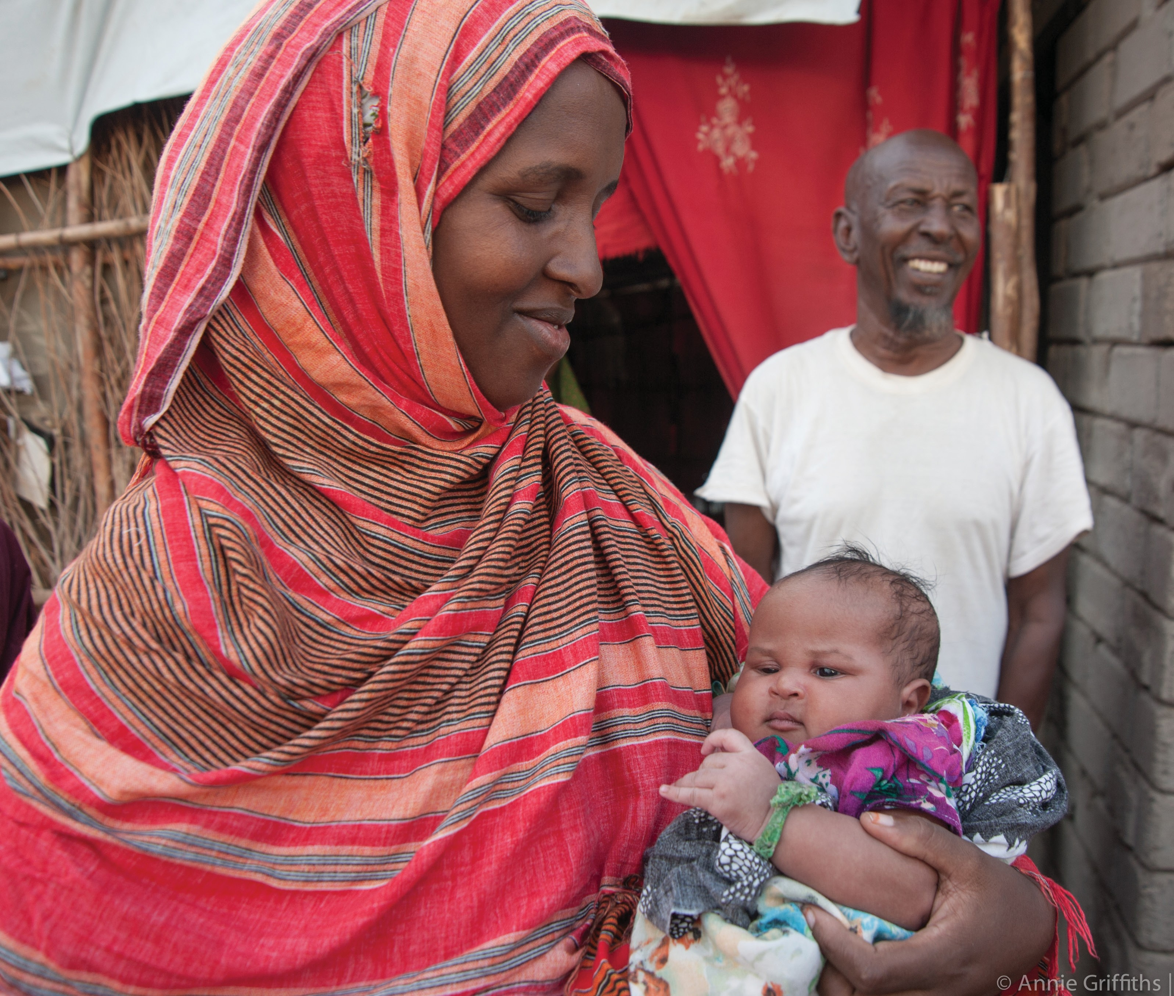
REFUGEES AND IMMIGRANTS WELCOME HERE.
#DOCWelcome

#GreaterAs1 I GreaterAs1.org
#RefugeesWelcome

