Let’s Raise Our Faith Voices to
Help Protect U.S. Refugee Resettlement!!

The beginning of October, the administration and Congress met to discuss the number of refugees to allow for resettlement in the US in FY2019, which began October 1st. Despite outcry from Members of Congress on both sides of the aisle, the administration reiterated that they will set the FY2019 resettlement goal at 30,000--an all-time low!

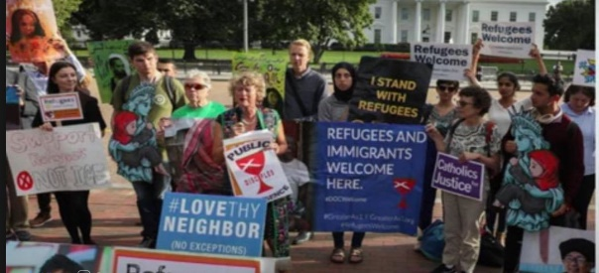
Disciples have been committed to refugee resettlement for DECADES, and many Disciples leaders—including our GMP, Regional Ministers, and many pastors-- spoke out strongly in support of refugees, and urged resettlement of at LEAST 75,000 refugees this year! Many recognize that such a LOW refugee goal of only 30,000 is directly at odds with our faith value of compassion, and with the reality of more than 25.4 million refugees in the world—the largest number ever!! See & share their inspiring testimonies here: http://bit.ly/2PuXb8N
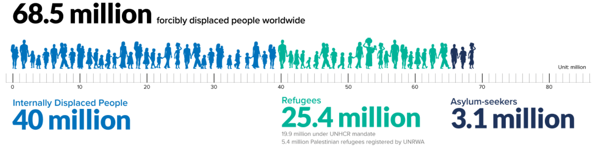

Therefore, it is critical that Members of Congress hear us urge that, at the very least, they must hold the administration accountable to resettling the full 30,000 refugees this year! Last year, the administration only admitted 21,000 of the 45,000 goal. This cannot happen again. We must protect refugee resettlement and rebuild the program.
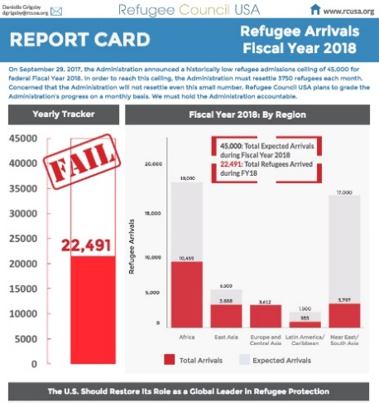
What Can We DO??
Call Your Senators and Representative Today!
Go to: http://bit.ly/2CEZqn1 to be connected to your Senators & Representative. Share personal stories, & here’s a sample script:
"I’m your constituent from [CITY/TOWN], and I am outraged that the administration has set the lowest refugee admissions goal in the history of the resettlement program - at just 30,000. I urge you to do everything in your power to see that, at the very least, the administration meets this goal. Last year the administration resettled less than half of its 45,000 goal, and this cannot happen again. Resettlement is a core American legacy that allows refugees to rebuild their lives. My community welcomes refugees, & I urge you to reflect our faith values by supporting refugee resettlement."

Contact Disciples Refugee & Immigration Ministries, Rev. Dr. Sharon Stanley-Rea, Director, at: sstanley@dhm.disciples.org, 202-957-7826, and go to http://bit.ly/DisciplesRIM
and bit.ly/2HxuDr0 for additional resources. Follow on Twitter @StanleyRea, and on FB.
Also, go here for more info.: https://greateras1.org/take-action-today-top-5-ways-to-protect-u-s-refugee-resettlement/.

