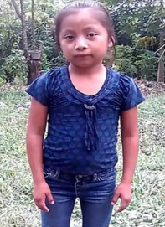
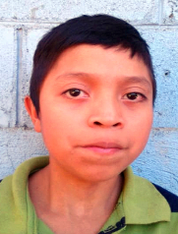
PRAYER VIGIL
FOR CHILDREN AND FAMILIES IN DETENTION AND AT THE BORDER
& IN MEMORY OF CHILDREN’S LIVES LOST
Sunday, July 21, 10 p.m.

WELCOME & GATHERING in the presence and memory of Governor Ray

LITANY FOR IMMIGRANT FAMLIES IN DETENTION (First prayed outside Dilley Detention Center in 2015.)
LEADER: Violence, poverty, and root conditions in which our own nation has been complicit drive adults, families, and children to leave their homelands. We pray for those seeking a safe haven in the United States.
PEOPLE: God of refuge, hear our prayer.
LEADER: Many of those fleeing are subject to additional forms of violence, such as sexual assault, on their journeys and during detention. We pray for an end to suffering and for love that can heal.
PEOPLE: God of refuge, hear our prayer.
LEADER: Studies continue to show there are harmful psychological effects on children and families held in detention, so we pray for the physical, emotional and mental healing of each who have been scarred.
PEOPLE: God of refuge, hear our prayer.
LEADER: Many held in detention have valid asylum claims and little access to legal counsel to address these claims. We pray their rights to due process and ability to gather evidence be recognized and available.
PEOPLE: God of refuge, hear our prayer.
LEADER: All of these concerns can be addressed with alternatives to detention, so we pray that community–based case management programs or release to family members and friends be explored.
PEOPLE: God of refuge, hear our prayer.
LEADER: We seek to welcome immigrants who arrive in our neighborhoods, contribute to our communities, and revitalize our congregations. We confess that incarceration of vulnerable individuals and families in unsafe conditions has resulted in the loss of lives for too many immigrants, at the same time as vast profits for prison companies. As we grieve with each family who has experienced dangers and loss, we pray for the courage to act for reversals of policies that constrict our compassion and for an end to detention that harms and separates families.
PEOPLE: God of refuge, hear our prayer, and empower our compassion and love! AMEN.

SONG: “O God, You Give Us Neighbors” (to the tune of “The Church’s One Foundation”)

TESTIMONY FROM A DISCIPLE—Family Impacts of Detention & Deportation

REMEMBRANCE OF CHILDREN WHO HAVE DIED—with lights, bells, & refrain, “Let freedom ring forever!”

MUSIC AND PRAYER

CHARGE--to go forward to shine your light, never forget lives lost, and act to seek freedom and justice
If you have not yet had a chance to do so, please consider signing and sharing our Disciples “Word to the Church here: https://disciples.org/ and see additional resources here for how you can help: https://www.discipleshomemissions.org/missions-advocacy/refugee-immigration-ministries/immigrants/
O God, You Give Us Neighbors
AURELIA 7.6.7.6 D ("The Church's One Foundation")
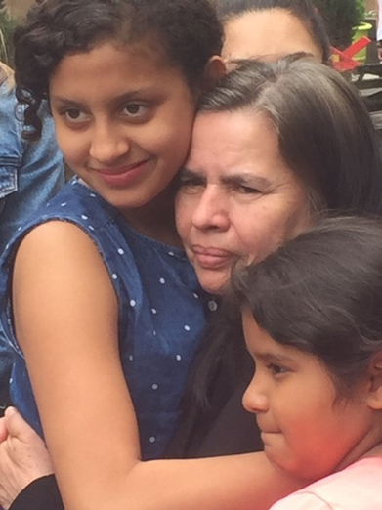
O God, you give us neighbors for whom your love abounds.
They've come here seeking refuge; they work here in our towns.
Their children go to school here; they come to church and pray.
O Lord, we grieve when neighbors are being sent away.

O God, you give us neighbors in this world that divides.
We see them at the border; they're struggling for their lives.
They're hurting by the roadside, and by the river, too.
You call us to show mercy to neighbors loved by you.

O God, you give us neighbors and call us all to see
our common fears and longings, our shared humanity.
You call us all to listen to burdens they have known,
to hear the truth they tell us, to see the love they've shown.

O God, you give us neighbors; and now, what must we do?
This question asked of Jesus is one we ask anew.
May we not make excuses and choose to walk on by
these neighbors fleeing violence — some sent back now to die.

God, may we work for justice for those who live in fear;
may we show Christ's compassion, and pray and persevere —
and by your Holy Spirit, in all we do and say,
may we stand up for neighbors now being sent away.
Biblical References: Luke 10:25-46; Leviticus 19:33-34; Leviticus 24:22; Matthew 25:31-46
Tune: Samuel Sebastian Wesley, 1864 ("The Church's One Foundation") (MIDI)
Text: Copyright © 2019 by Carolyn Winfrey Gillette. All rights reserved.

Support Chants:
No Hate! No fear! Immigrants are welcome here! No Hate! No fear! Refugees are welcome here!
Se ve, se siente! El pueblo esta presente! (It can be seen. It can be felt. The community is here.)
When immigrants are under attack, what do we do? Stand up, LIGHT back!
What do we want? Welcome! When do we want it? NOW! To show your welcome, do this more—Open hearts & open doors!
No estan solos! (You are not alone.)

