O God, You Give Us Neighbors
AURELIA 7.6.7.6 D ("The Church's One Foundation")

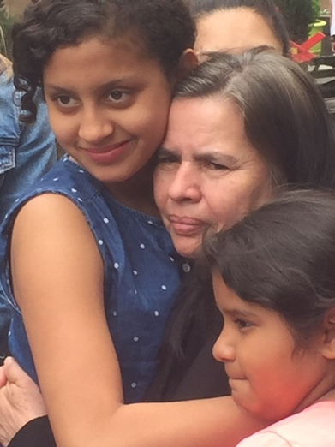
O God, you give us neighbors for whom your love abounds.
They've come here seeking refuge; they work here in our towns.
Their children go to school here; they come to church and pray.
O Lord, we grieve when neighbors are being sent away.

O God, you give us neighbors in this world that divides.
We see them at the border; they're struggling for their lives.
They're hurting by the roadside, and by the river, too.
You call us to show mercy to neighbors loved by you.

O God, you give us neighbors and call us all to see
our common fears and longings, our shared humanity.
You call us all to listen to burdens they have known,
to hear the truth they tell us, to see the love they've shown.

O God, you give us neighbors; and now, what must we do?
This question asked of Jesus is one we ask anew.
May we not make excuses and choose to walk on by
these neighbors fleeing violence — some sent back now to die.

God, may we work for justice for those who live in fear;
may we show Christ's compassion, and pray and persevere —
and by your Holy Spirit, in all we do and say,
may we stand up for neighbors now being sent away.

Biblical References: Luke 10:25-46; Leviticus 19:33-34; Leviticus 24:22; Matthew 25:31-46
Tune: Samuel Sebastian Wesley, 1864 ("The Church's One Foundation") (MIDI)
Text: Copyright © 2019 by Carolyn Winfrey Gillette. All rights reserved.

