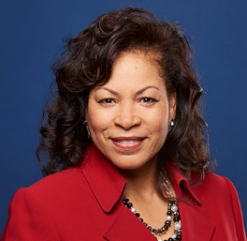
Dee Long is the Pension Fund Area Director serving South Carolina, North Carolina, Virginia and the Capital Area. One of the most important things we do as the Pension Fund is sustaining persons in ministry. Ministry is a unique calling and we understand the challenges that come with it. We look out for you by providing robust retirement benefits and financial education, so you can focus on your ministry and serving others. We offer products for every life stage.

Dee holds a B.A. in Communications from the University of Memphis in TN and is a graduate of Rutledge College, Raleigh, NC. She is an Elder of the National Convocation and the immediate past president of the Ministers’ Wives and Husbands Fellowship of the National Convocation. Prior to working with the Pension Fund, she served as a Congregational Services Consultant for eleven years with Church Extension.

She has served on numerous boards throughout the church and developed broad church connections including Southeast Regions; Church of Christ-Disciples of Christ; affiliated fellowships of the National Convocation and the network of Disciples Women. She is an accomplished workshop leader, keynote speaker and gifted singer. She now resides in Indianapolis, IN with the love of her life, Sotello who serves as the President of Disciples Home Missions.

Dee is your point person in connecting you with the Pension Fund to help you achieve a Smart, Strong and Secure retirement!

