Biography (Civilian)
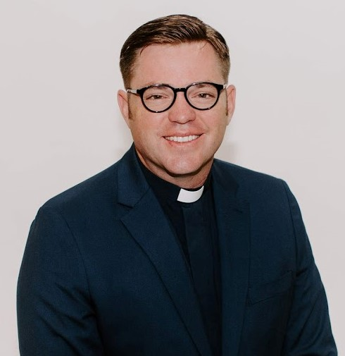
The Rev. Dr. Jonathan R. Fisher is a Certified Educator Candidate (CEC) fellow with the US Army’s CPE System in San Antonio, TX. He is currently an active duty Army Chaplain, serving at the rank of Major. Jonathan has over 15 years of military chaplaincy experience on active duty and in the National Guard. His service includes 3 combat tours, a diverse collection of units both operational and training as well as completing a CPE residency at Madigan Army Medical Center in Tacoma, WA. In addition to his military service, he has served as associate pastor, high school educator, and worship pastor. He is endorsed through the Christian Churches (Disciples of Christ). His ordination was recognized by the Disciples in 2010 after an extended time of growth, discernment, and spiritual direction. Jonathan’s story includes traumatic experiences in a fundamentalist education and in combat which led him to embrace values and a faith best expressed in the Disciples.
Jonathan’s Doctor of Ministry (Erskine Theological Seminary) focused on ministry in a military prison. He completed it while assigned as staff chaplain to the Military Correctional Complex on Ft. Leavenworth, KS. His work included developing and teaching a course that resulted in a dramatic reduction of violence and recidivism at the MCC, which includes the Joint Regional Correctional Facility and United States Disciplinary Barracks, the DoD Maximum Security Prison. Jonathan received his MDiv from Luther Rice Seminary and also holds an MA in Ministry (LRS) and BA in Music and Theology (PCC).

Biography (Military)
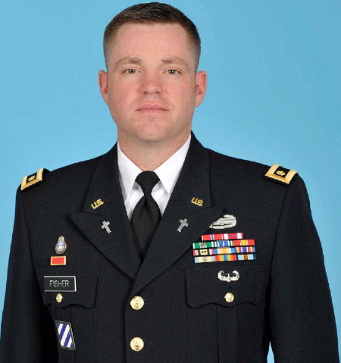
Chaplain (Major) Jonathan R. Fisher
CH (MAJ) Jonathan R. Fisher is a native of Reed City, Michigan. He holds a BA in Music and Theology, an MA and MDiv from Luther Rice Seminary, as well as a Doctor of Ministry from Erskine Theological Seminary. His Army education includes the Chaplain Officer Basic Course, Chaplain Career Course, and the Air Assault School. He is a clinical chaplain having graduated from the MEDCOM Clinical Pastoral Education program and is currently pursuing Certified Educator through the Association of Clinical Pastoral Education at Brooke Army Medical Center. CH Fisher is an ordained minister in the Christian Church (Disciples of Christ).
Before becoming an Army chaplain, CH Fisher served as associate pastor, worship leader, and high school teacher in Georgia and New Jersey. CH Fisher was commissioned as a Second Lieutenant in the Georgia Army National Guard in September 2004 assigned to Joint Force Headquarters Atlanta, GA. In 2005, he was assigned to 2-121st Infantry Battalion, Fort Stewart, GA. He then deployed to Iraq in support of Operation Iraqi Freedom under the Third Infantry Division, Task Force Baghdad. He was mobilized again in the 188th Infantry Brigade, Ft. Stewart, GA in support of Operation Warrior Trainer. He served as an Observer, Controller, and Trainer with that unit on Ft. Stewart until he entered Active Service in February of 2008. He immediately deployed to Iraq again and served as the Battalion Chaplain for the 603rd Aviation Support Battalion, 3rd Infantry Division in Baghdad, Iraq. After returning to Hunter Army Airfield, he was reassigned to the 832nd Ordnance Battalion, at Redstone Arsenal, AL. He was then selected to attend the Clinical Pastoral Education course at Madigan Army Medical Center, Ft. Lewis, WA. Following his CPE residency, he was assigned to the 15th Military Police Brigade where he served as the staff chaplain at the Joint Regional Correctional Facility and United Sates Disciplinary Barracks Fort Leavenworth, KS. After completing the Chaplain’s Career Course at Ft. Jackson, SC, CH Fisher was assigned to the 2-44 Air Defense Artillery Battalion on Ft. Campbell, KY where he deployed to Operation Inherent Resolve with the 101st Airborne Division in Iraq. Upon returning, he became the brigade chaplain for the 101st Airborne Division (Air Assault) Sustainment Brigade. He currently is a Certified Educator Candidate at Brooke Army Medical Center, San Antonio, TX.
In April of 2005, Jonathan married Sara Nave of Cedar Springs, Michigan. She is also an ordained minister and has served churches in SC and KY. She currently serves as the senior pastor of Rolling Oaks Christian Church, San Antonio, TX. The Fishers have three children, Sophia (12), Ransom (10), and Lenora (8). They reside in Schertz, TX.
CH Fisher’s Awards include: the Bronze Star Medal, the Meritorious Service Medal (2OLC), the Army Commendation Medal (3OLC), the Army Achievement Medal, the National Defense Service Medal, the Iraq Campaign Medal with two stars, the Operation Inherent Resolve Campaign Medal, the Global War on Terrorism Medal, the Armed Forces Reserve Mobilization Medal, the Army Service Ribbon, the Overseas Service Ribbon with the numeral 2, the Combat Action Badge and the Meritorious Unit Commendation (1OLC).

