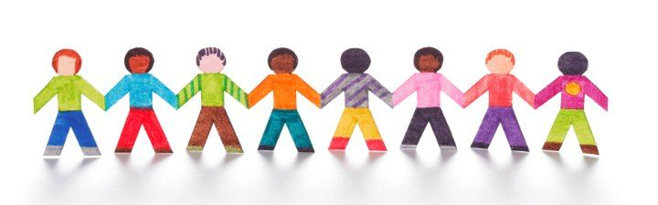

Paper Doll Instructions for Your #FreeTheFamilies Vigil
Consider making 260 paper dolls in a chain for the Free the Families Vigil to urge families and children be released from family detention. 260 is the total number of children and parents detained in the three centers in Dilley and Karnes City, Texas, and in Berks County, Pennsylvania.
You may hold your doll chains, or attach them in clusters to 3-4 foot tall wooden dowels.
There are 2 different templates of doll patterns (see separate document). You can choose just one, or make a mix of the two styles. Both paper doll templates have been sized for you to make sets of 3 dolls on each 8.5 x 11 size piece of paper.*
- Print out at least one template for you to cut out the right size and shapes. Feel free to use white or colored paper.
- Cut out the paper dolls, using the template to cut along the outlines. Depending on the paper and scissors you use, you can stack 2 or 3 sheets of paper with one template. Please cut all along the black lines so that we can see the actual shapes.
- Color the dolls with crayons or markers. We would love to have lots of different colors and styles of clothing, skin tones, facial features and even hair styles.
- Tape together your sets of 3 paper dolls to make longer chains.
- Deliver your finished paper dolls to your event organizer ahead of time, to ensure the full 260 will be on display.
Note: *If you have access to a roll of butcher paper or craft paper, you can fold the paper in a way to make longer doll chains without using tape.

If you have any questions, please contact Sharon Stanley-Rea at Disciples Refugee & Immigration Ministries, 202-957-7826, or sstanley@dhm.disciples.org.

