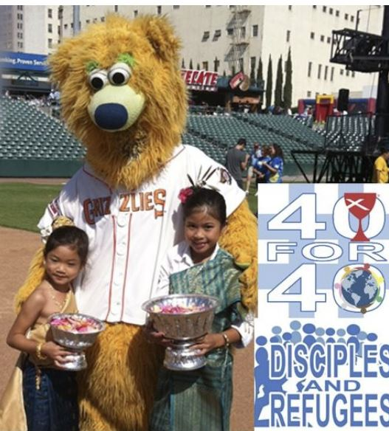
DISCIPLES REFUGEE ACTION TOOLKIT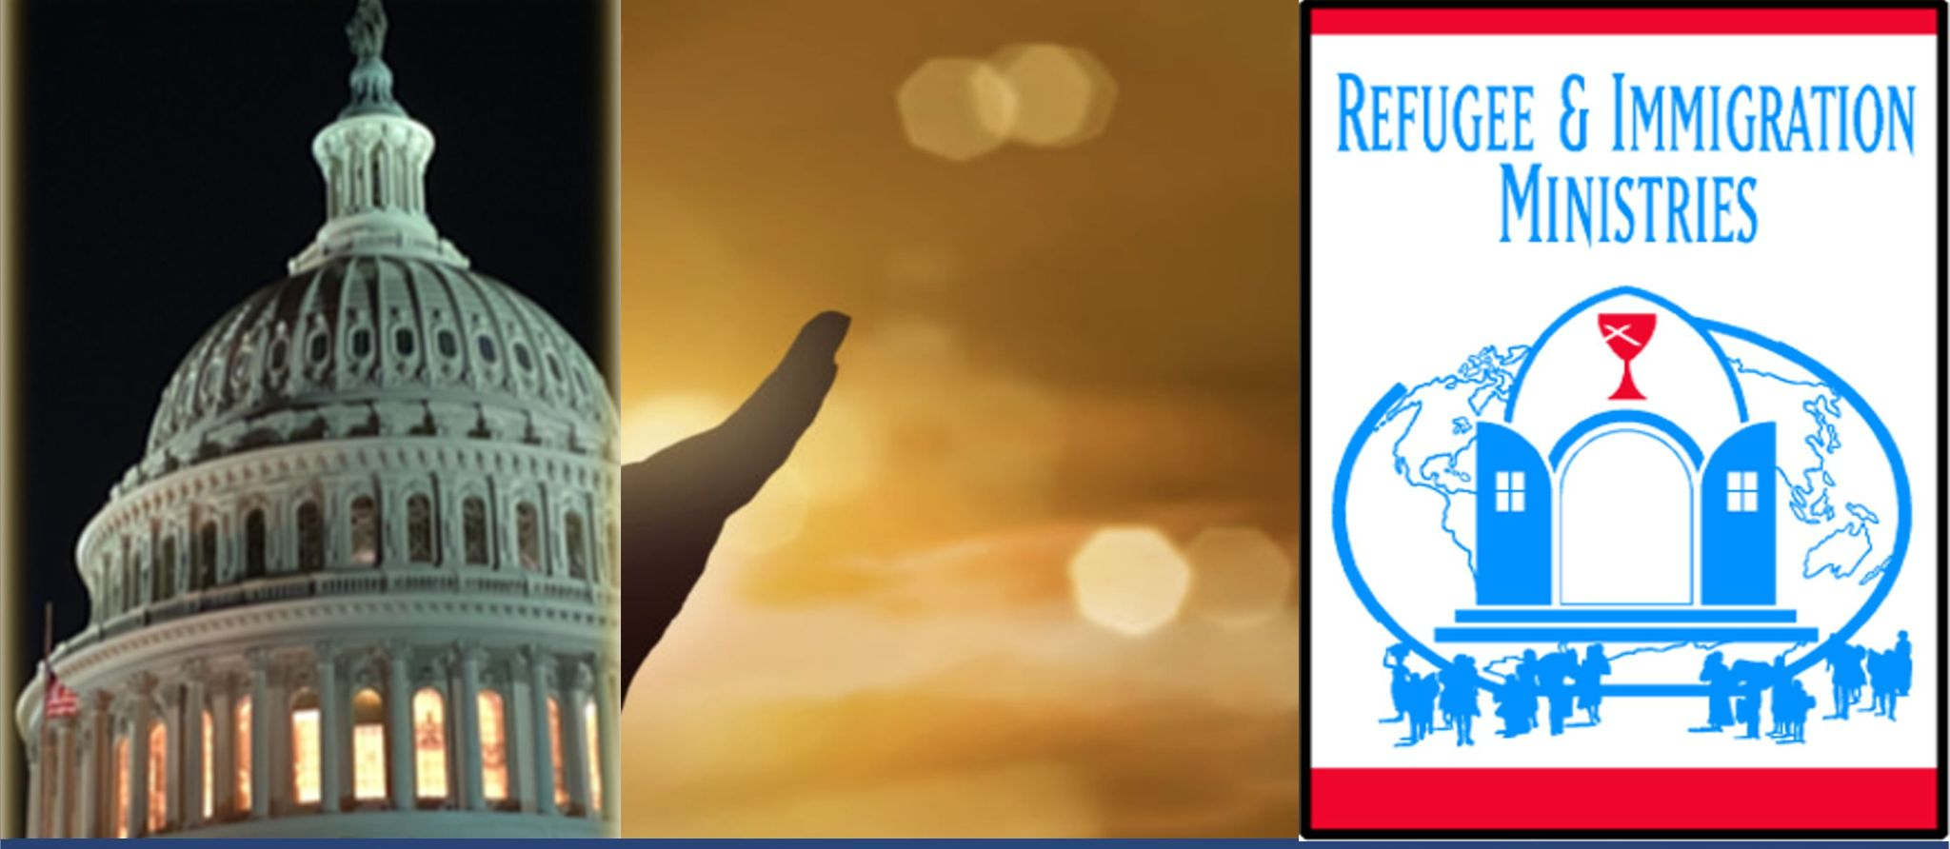

Disciples Are Needed to Offer Our Faith Voices to Demonstrate Our Readiness to Welcome & Urge the U.S. to Restore & Strengthen Refugee Resettlement & Asylum Protections

Questions? Contact Disciples Refugee & Immigration Ministries Director, Rev. Dr. Sharon Stanley-Rea, sstanley@dhm.disciples.org,or 202-957-7826

Share this Toolkit: http://bit.ly/RefugeesWelcomeToolkit
with your friends & congregation!

June 2021

Background: Shortly after taking office, President Biden promised to raise THIS YEAR’s U.S. Refugee resettlement numbers to 62,500. Yet on Friday, April 16th, the Biden administration announced that it would keep the historic-low refugee admissions goal of 15,000 in place for the remainder of this fiscal year, despite promising to raise the goal to 62,500. Later that day--after hearing strong resistance from faith and community advocates, the administration backed off, and said it may name a “final, increased refugee cap” in mid-May. Multi-faith leaders, including Disciples, responded to the administration’s concerning actions through this Press Release, which also links to letters from heads of communion and faith leaders from around the country.

Then on May 3rd, President Biden responded to advocates’ many requests, and fulfilled his promise of raising the US refugee cap to 62,500. Likewise, the administration removed restrictive categories of refugees put in place previously; instead returning to broad geographical allocations for refugees based on vulnerability.

Nonetheless, restoring refugee resettlement is lengthy, and thousands of refugees continue to remain in limbo. Due to the delay in announcing a higher refugee resettlement number, thousands of refugees who were vetted and ready for travel to the United States have already seen their medical and security checks start to expire. This has forced refugees to now have to wait months or years to be resettled and reunited with their loved ones.

Our Disciples General Minister & President Rev. Terri Hord Owens, head of Week of Compassion Rev. Vy Nguyen, and Disciples Refugee & Immigration Ministries’ Director Rev. Dr. Sharon Stanley-Rea participated in March in an ecumenical meeting with Biden administration officials to request a higher refugee cap. The ecumenical gathering likewise affirmed an Ecumenical Declaration to Expand Welcome.

It is critical that the administration and Members of Congress hear our faith voices urge we resettle as many refugees as possible in the current fiscal year, and also urge for 125,000 refugees to be resettled in the year ahead (beginning October of 2021). Make your voice heard TODAY to say you are ready to welcome refugees, and are eager to see our welcoming heritage restored!

TOP 5 WAYS TO TAKE ACTION:
As World Refugee Day approaches on June 20th

1.SHARE these Disciples graphics on social media to show your commitment to welcome refugees. Like and tag Disciples Refugee & Immigration on FB at: http://bit.ly/RIMFacebook, on Twitter: @StanleyRea, and on Instagram as sharonstanleyrea, then download and share the images on your social media, with sample messages like these:

It's good @DisciplesNews that our congregations are ready to be a part of #RestoringWelcome by resettling 62,500 refugees this year, & rebuilding our US heritage of #RefugeesWelcome by raising resettlements to 125,000 in FY2022! Please help us welcome as our faith urges, @POTUS!

@DisciplesNews General Minister & President @terrihordowens joined other faith leaders in: https://cwsglobal.org/wp-content/uploads/2021/03/March-2021_-Ecumenical-Declaration.pdf to raise voice for #RestoringWelcome & say #RefugeesWelcome; as scripture calls us to "welcome the sojourner" who may be "angels unawares." #WRD2021 #WorldRefugeeDay

.@DisciplesNews are ready to be a part of #RestoringWelcome by resettling 62,500 refugees this year, & rebuilding our nation’s heritage of #RefugeesWelcome by raising resettlements to 125,000 in FY2022!

2. SEND this Disciples Resettle 62,500 This Year & Raise to 125,000 for Next Postcard to the President and your legislators. Download and send to the Administration at: President Joe Biden, The White House, 1600 Pennsylvania Avenue, N.W., Washington, DC 20500, and to your US Senators and US Representative. Find your Representative, and click on their name for their website to find their physical address.

3. CONTACT your U.S. Senators & Representatives. Congress must hold President Biden accountable. Click here for an action alert to connect with your Members of Congress. Or, consider writing a Press Release or Editorial or Letter to the Editor about your congregation’s work with refugees, to share publicly that you are ready to restore welcome for refugees! Click here for a sample press release.

4. MAKE PLANS to celebrate WORLD REFUGEE DAY & REFUGEE WELCOME SUNDAY on June 20! Find Disciples planning materials for your congregation HERE--and keep looking for additional resources to continue to be added! Also, find even more resources in our Faith Partners World Refugee Day Toolkit HERE, and find HERE a special Faith Toolkit of Vigil and Prayers materials to End the “Title 42” practice that continues to harm asylum seekers.

5. WRITE an Opinion Editorial or Letter to the Editor, or mobilize a local or virtual action or Press Conference now! Click here for a sample op-ed and email pitch to the editors. Click here for sample steps to organizing your own response event.

Additional Resource Links:
- 42 Heads of Communion and High Level Faith Leadership Letter to Biden to Sign Revised FY21 PD and Press Release
- 488 Faith Leaders and 133 Faith-Based Organizations Letter to President Biden to Sign Revised FY21 PD and Press Release
- 200+ Local, State, and National Organizations Letter Urging President Biden to Sign a Revised Refugee Admissions Goal and Press Release
- RCUSA Refugee Arrivals Mid-Year Report 2021
More Information to Mobilize a local or virtual action or press conference for/ahead of World Refugee Day on June 20th:
Here are steps you can take for a successful event that communicates you and your community are READY to restore the US refugee program and to welcome refugees!:
- Engage a team of refugee agencies, volunteers and refugee leaders who are committed to acting swiftly on this issue.
- If you decide on doing an in person event, make sure that you have the event outside and follow the CDC guidelines for social distancing and mask wearing. Or consider an event such as a car rally where participants can stay safely in their cars.
- Agree on goals and desired outcomes for your virtual or local event.
- Invite the media to cover the event. Write a media advisory before the event and/or media release after the event. Capture quotes from key leaders ahead of time as part of the release you send.
- Explore ways in which you can tie the event to the reality of COVID-19 response, such as highlighting essential refugee workers and providing time to hear their testimonies.
- Identify someone who can lead the technical aspects of online activity. Make sure to test your tech ahead of time to ensure everything is working properly. Consider live streaming options on social media, recording, and promoting the event ahead of time as ways to further your reach.
- Identify speakers and make sure to centralize refugee voices. Collaborate on preparation for story telling, top line messages, advocacy asks and focus on strategic decision makers. Consider inviting an elected official who has been a champion on refugee resettlement to be a speaker.

