ASSOCIATION OF DISCIPLE MUSICIANS
FEBRUARY 2024

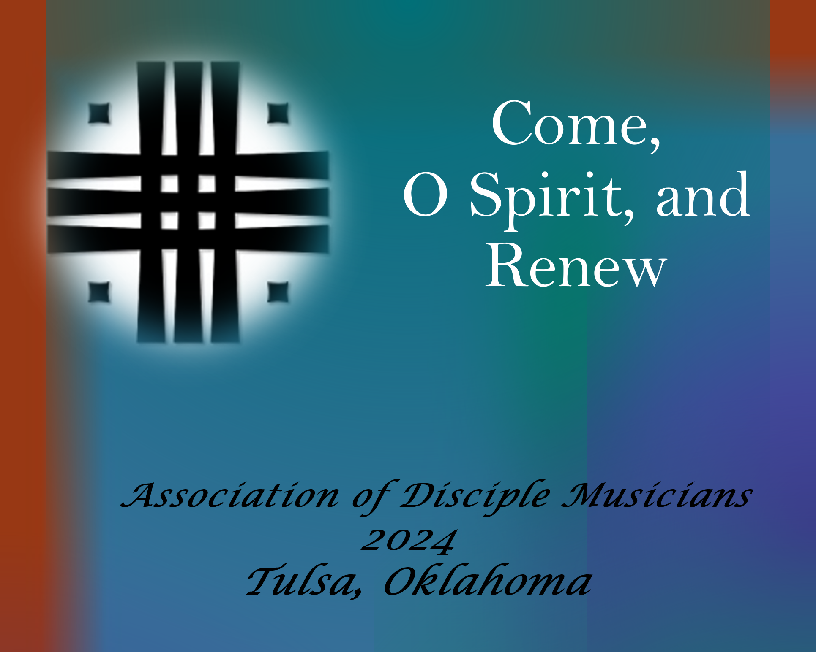
The ADM 2024 Conference for Music and Worship will be in Tulsa at Harvard Ave. Christian Church on July 22 - 26. Now’s the time to mark your calendars and plan to be with the ADM family this year! The Conference Registration Form is attached for you to print off and mail in with a check, money order, or credit card information to Disciples Home Missions, c/o Anne Marie Moyars, PO Box 1986, Indianapolis, IN 46206.

More About the 2024 Clinicians
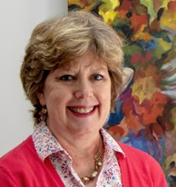
Rev. Nancy Pittman, Traditional Worship ⁓ Born on the high plains of Texas, Dr. Nancy Claire Pittman’s earliest images of God were shaped by the vastness of the great North American prairie, limited only by shimmering sunrises and dazzling sunsets. And her earliest encounters of Christian community took place in the sprawling structures of First Christian Church, Amarillo, and the intimate Ceta Glen Christian Camp located in a finger of Palo Duro Canyon. She embraced in these places the wideness of God’s mercy and the unity of abiding friendship in Jesus.
Her faith commitments were further formed and informed through her work in the Religion Studies and Psychology departments of Texas Christian University where she earned a BA, and at Brite Divinity School where she was awarded an MDiv. Having known a sense of call to ministry since childhood, she was ordained by the Christian Church (Disciples of Christ) in the Southwest on April 1, 1984. She has served as a minister in several churches across Texas or Oklahoma and preached or lectured as a guest speaker in numerous congregations and regional and national events.
The centrality of the Bible for Christian life and faith that Disciples have claimed since their founding led Dr. Pittman to earn a PhD in New Testament Studies at Southern Methodist University in 1996. Her dissertation explored images of Jesus the Christ in the Book of Revelation as clues for the demands made upon the followers of Jesus for the first readers of that wondrously strange writing. Her first faculty position was at Tainan Theological College and Seminary, a school related to the Presbyterian Church of Taiwan. There she and her husband, Dr. Don A. Pittman, served together for six and a half years as mission partners sent by Global Ministries of the Christian Church (DoC).
Dr. Pittman joined the faculty of Phillips Theological Seminary as the Director of the Doctor of Ministry program in 2005. In that position and then later as dean (2013-2018) she has explored the intersection of practical ministry with intelligent and learned theological and biblical reflection. At the seminary she teaches “Capstones in Theological Leadership” as an invitation to graduating students to live at that intersection throughout their vocational lives. She also continues to be challenged by images of faithful and faithless community in the New Testament, understandings of ministerial leadership in the 21st century, and our own contemporary ecclesiolatries—idolatries of church and church forms.
Currently, Dr. Pittman is President and Stephen J. England Associate Professor of the Practice of Ministry at Phillips Theological Seminary in Tulsa, an ecumenical seminary affiliated with the Christian Church (Disciples of Christ). In her spare time, she laughs with her family, reads novels, and embroiders flowers. Nancy was Worship Clinician for the 2012 Conference in Tulsa.
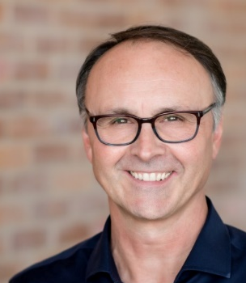
Jeff Elkins, Modern Worship ⁓ Jeff Elkins currently serves as the Minister of Worship at First Baptist Church, Tulsa, Oklahoma. Jeff oversees a music ministry that spans all ages, including preschool/children and youth choirs, adult choirs, orchestra, bands, and various vocal ensembles. Jeff leads both modern worship services and traditional worship services at his church.
Jeff’s passion, no matter the style of music, is to connect the heart of the congregation to the Heavenly Father through singing and worship. Jeff has a BA in music from Northeastern State University and a MM in conducting from the University of Arkansas. Before coming to Tulsa, Jeff was on the faculty as NSU and Minister of Music at FBC in Muskogee, Oklahoma.
Jeff is an active member of the Singing Churchmen of Oklahoma and former President of the Baptist Church Music Conference. Jeff has contributed to several devotional books as well as to Tim Sharp’s book, Sacred Choral Repertoire, Insights for Conductors. Jeff is celebrating 36 years of marriage to his wife, Jane, and they have three beautiful daughters and seven amazing grandchildren. Jeff served in a similar capacity with the 2012 ADM Conference at First Christian Church, Tulsa.
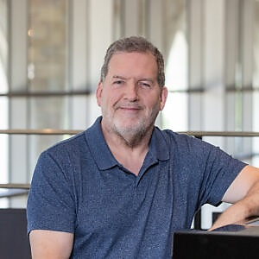
Dr. Kim Childs, Choral ⁓ Dr. Kim Childs, Professor of Choral Studies and Voice at the University of Tulsa, directs the Cappella Chamber Singers and TU Chorale, as well as teaching choral conducting, choral literature, choral seminar, and private voice.
Cappella Chamber Singers have been featured at Carnegie Hall, in Oklahoma Centennial Concerts, Brown Bag-It Series at the Tulsa PAC, the prestigious Bernsen Concert Series at First Presbyterian Church, and chosen as one of the top choirs with the Oklahoma Music Educators Association twice during his tenure at TU. Dr. Childs has conducted the Vaughan Williams Mass in G Minor, Duruflé Requiem, Mozart Requiem, Britten Rejoice in the Lamb, Pinkham Christmas Cantata, Vivaldi Gloria, Handel Messiah, Mozart Coronation Mass, Fauré Requiem, and many other choral works. He has studied conducting with Dr. Deanna Joseph of Georgia State University, Dr. Joe Miller of Westminster Choir College, Simon Carrington at the Norfolk Chamber Music Festival, and Jerry McCoy, past President of the American Choral Directors Association.
Dr. Childs also performs regularly as solo tenor; a notable concert was the Tulsa Chorale performance of the Ralph Vaughan Williams Hodie in November 2019. He has sung with numerous professional choirs, including the American Bach Solists, Carmel Bach Festival, Dallas Bach Society, and most recently with the Oklahoma Bach Choir. Kim is also Chancel Choir and Handbell Choir director at College Hill Presbyterian Church, Tulsa.

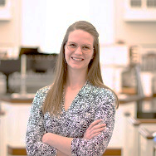
Carolyn Manning, Co-Organ ⁓ Carolyn is a recent graduate of the Oklahoma City University, having obtained a Master of Music degree in organ performance. Her undergraduate degree is in music, biology, and chemistry from the University of North Texas.
Currently, Carolyn serves as principal keyboardist at Mayflower Congregational Church and also sings and plays viola where appropriate. She also works full time as a tuning and maintenance technician with Red River Pipe Organ Company out of Norman.
When not working, Carolyn enjoys spending time with her wife, Jacy, and their eight (!) fur babies. She loves nurturing plants, animals, and humans, and is happiest while learning and practicing whatever skill has her interest that day.

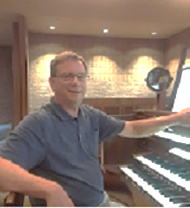
Rev. Larry Sivis, Co-Organ ⁓ Larry Sivis, was born in Danville, KY and grew up in both Alabama and Kentucky. He holds both the Bachelor or Music and the Master of Music Degree in Organ Performance from the University of Kentucky and a Master of Divinity Degree from Lexington Theological Seminary with a focus in Worship and Church Music. Larry has served Disciples of Christ and United Methodist congregations in Virginia, Tennessee, Texas, Ohio, and Kentucky.
Larry has served twice on the National Planning Council of the Association of Disciple Musicians and held the office of President in 1991 and 2001. From 1991 to 1995, he served on the hymnal development committee for the Chalice Hymnal. As a contributor to the hymnal, he has seven compositions and arrangements that were included, and he chaired the Psalter subcommittee. Larry was also a contributing writer to the Worship Leader’s Companion to the Chalice Hymnal. He has also served ADM as convener for strategic planning and in 2010 as Co-Worship Clinician for the 2010 conference in Lexington, KY.
Larry’s leadership on the regional and general level of the church has included Chair of the West Area Board of the Christian Church in Kentucky, a Vice Moderator of the Christian Church in Kentucky, and was the General Assembly organist in Columbus, Ohio. He currently serves as the chaplain of the Lexington Kentucky Chapter of the American Guild of Organists and has taught worship courses in the Licensed Minister’s School for the Christian Church in KY.
From 2007 to 2023, Larry served as the Associate Minister and Minister of Worship at First Christian Church, Ashland, KY. He currently has stepped out of retirement and is serving as the Organist and Director of Music at Calvary Episcopal Church, in Ashland. Larry’s wife, Debbie, is recently retired as Executive Director of the non-profit Shelter of Hope in Ashland. Their daughter, Betty Jean, is the Senior Minister of Perry Christian Church in the greater Cleveland area.

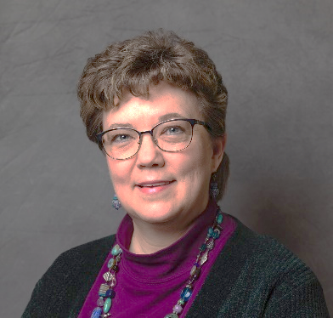
Tammy Waldrop, Handbells ⁓ Tammy Waldrop is a graduate of Baylor University (‘80 & ‘85) with both a Bachelor’s and Master’s degree in Music Theory with an emphasis in Composition. Tammy has been writing and arranging for handbells and vocal choirs since 1980, placing over 400 publications with 19 publishers. She has held music editor positions at Word Music, Ring Out! Press, and Alfred Music Publishing and has served on the music staff of numerous churches in various denominations.
Tammy is a frequent clinician/director for workshops, music weeks, and festivals across the country. She is past Musical Director for the Community Handbell Ensemble, Strikepoint of Texas. Currently she is co-director of Musical Arts at First Presbyterian Church of Kingwood, Texas. Tammy enjoys vegetable and herb gardening, cheese making, writing children’s fiction and breeding and showing dogs. She resides in New Caney, Texas with her husband, Emanuel Hollander and five American Eskimo dogs: Hanzie, Lillie Belle, Finn, Farley, and Tulip. Tammy was the Handbell Clinician for the 2012 Conference in Tulsa.

What you don’t want to miss and much more!
A Worship and Music Conference not to be missed.
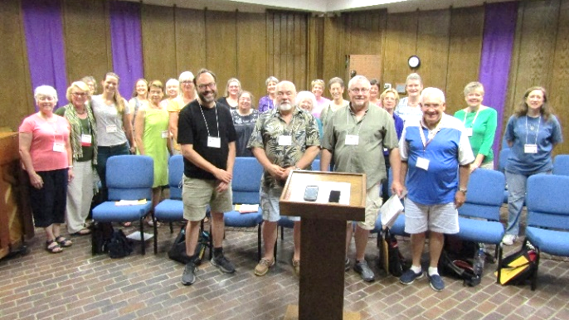
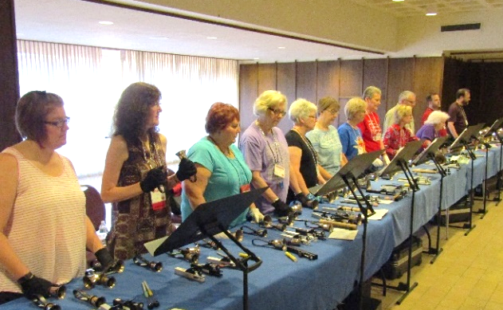
July 22 – July 26, 2024
Singers abounding! Handbells always ringing!

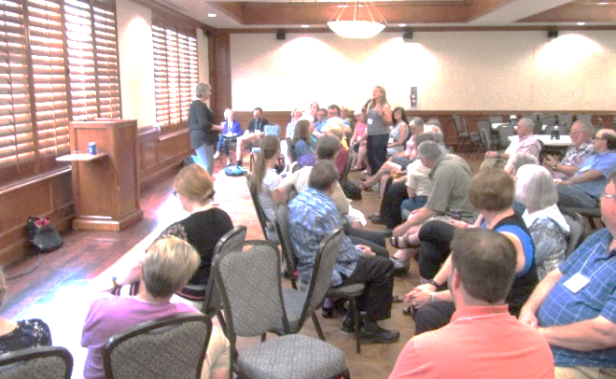
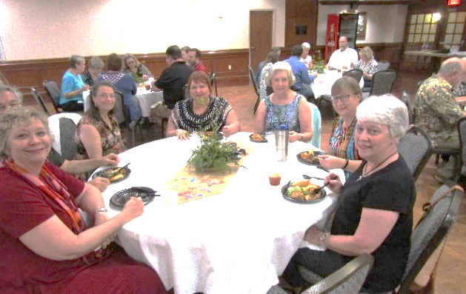
Fellowship with meals! Sessions for Learning and Sharing!

A Sampling of Conference Activities
There should be plenty to meet your needs and keep you busy from the time the conference begins with Registration at 3:00 on July 22 through the Closing Worship Service and Lunch on July 26.
Organ Techniques Large Choir Anthem Reading
Advanced Handbells Small Choir Anthem Reading
Building Modern Worship Handbell Reading Session
Children’s Ministry Free Time for Dinner One Night
Chapel Choir Modern Worship Service
Beginning Handbells Traditional Worship Service
Instruments in Worship Blended Worship Service
Worship Round-table Discussions Worship Seminar
Personal Development Catered Lunches & Dinners
Worship Technology Organ Crawl
Choral Directing Techniques Annual Business Meeting
Hymn Accompanying Fellowship Time
ADM Chorus Closing Circle
Choir Resources Council Meetings
Sacred Piano Literature Communion in Worship
Worship Design Offertory for ADM Funds
Opening Hymn Festival Closing Worship Service

